How to disable your browser's popup blockers
The following includes steps for disabling pop-up window blockers.
- Internet Explorer 7 (WindowsXP)
- Internet Explorer6 (Windows XP)
- Firefox (Windows PC)
- Firefox (Mac OSX)
- Mozilla (Mac OSX)
- Safari (MacOSX)
The following includes steps for disabling Brower toolbars.
- Yahoo toolbar popup blocker
- Google toolbar popup blocker
- AOL toolbar popup blocker
- MSN toolbar popup blocker
- Norton Internet Security/Personal Firewall popup blocker

How to disable Internet Explorer 7 popup blocker (Windows XP)
- From the Tools menu, select Internet Options.
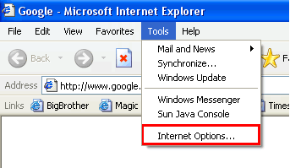
- From the Privacy tab, uncheck Turn on Pop-up Blocker and click "OK".
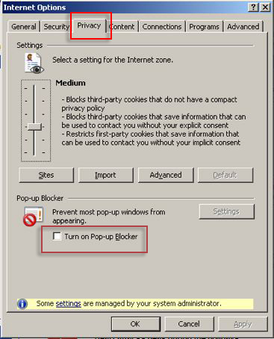
For more information on Internet Explorer popup blocker please go tohttp://www.microsoft.com/windowsxp/using/web/sp2_popupblocker.mspx
Back to top

How to disable Internet Explorer 6 popup blocker (Windows XP)
- From the Tools menu, select Internet Options.
- From the Privacy tab, uncheck Block pop-ups.
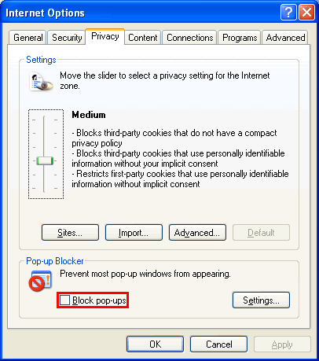
For more information on Internet Explorer popup blocker please go tohttp://www.microsoft.com/windowsxp/using/web/sp2_popupblocker.mspx
Back to top

How to disable the Firefox popup blocker (Windows PC)
- From the Tools menu, select Options.
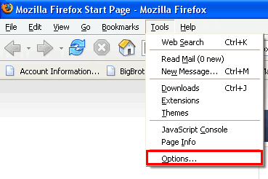
- From the Content tab, uncheck Block Popup Windows and click "OK".
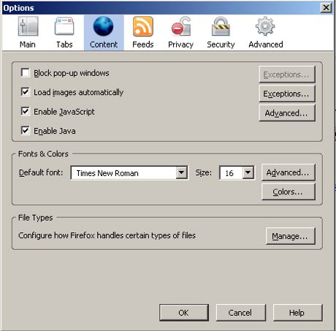
Back to top

How to disable the Firefox popup blocker (Mac OSX)
- From the Firefox menu, select Preferences.
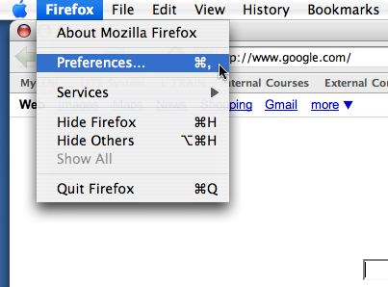
- From the Preferences window, choose the Content button and then uncheck Block Pop-up Windows.
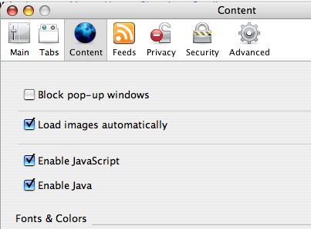
Back to top

How to disable the Mozilla popup blocker (Mac OSX)
- From the Mozilla menu, select Preferences.
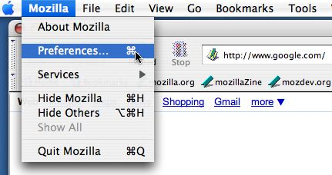
- From the Privacy & Security tab, choose Popup Windows. Uncheck Block unrequested popup windows, and click "OK"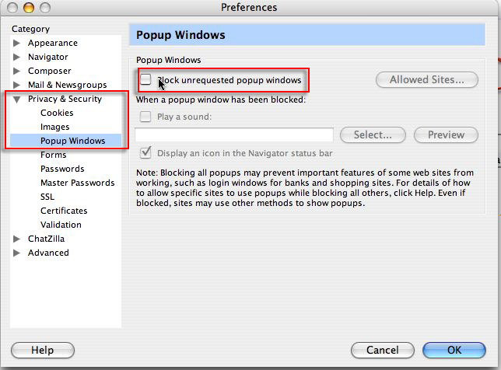
Back to top

How to disable the Safari popup blocker
- From the Safari menu, make sure Block Pop-Up Windows is unchecked.
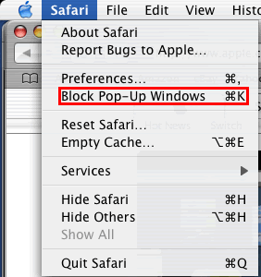
Back to top

How to disable the Yahoo toolbar popup blocker
- Locate the Popup blocker icon and click the down arrow.
- Uncheck Enable Pop-Up Blocker.
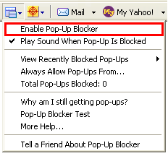
For more information on the Yahoo toolbar please go to http://toolbar.yahoo.com.
Back to top

How to disable the Google toolbar popup blocker?
- Click on the Google logo on the Google toolbar and select Options.
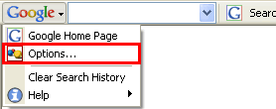
- Uncheck Popup Blocker, and then click OK.
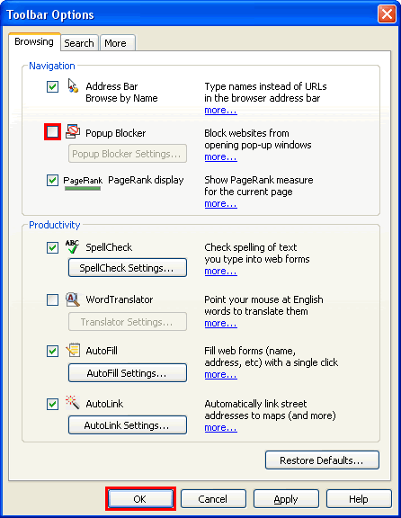
For more information on the Google toolbar please go to http://toolbar.google.com.
Back to top

How to disable AOL toolbar popup blocker?
- Locate the Popup blocker icon.
- Click on it until it says Allowed.
Back to top

How to disable the MSN toolbar popup blocker?
- Locate the Popup blocker icon and click the down arrow.
- Check Allow Pop-ups.
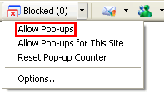
For more information on the MSN toolbar please go to http://toolbar.msn.com.
Back to top

How do I disable my Norton Internet Security/Personal Firewall popup blocker?
- Open Norton Internet Security's/Firewall�s main window (you may click the firewall icon on the system tray or use Start->Programs->Norton Firewall)
- Click the Ad Blocking line.
- Click the Turn Off button.
